Name: Muhammad Shoaib Akhter Qadri

Enrollment No: 02-131212-009

Reg No: 79290

Course: Embedded System

Q: 01) Design an embedded system which control the LED and a 90 watt bulb through web server physical which is interface with Arduino UNO along with Ethernet shield. Following web page is example like control the LED so in this you needs to add one more option for bulb.

**Arduino IDE Image Output:**

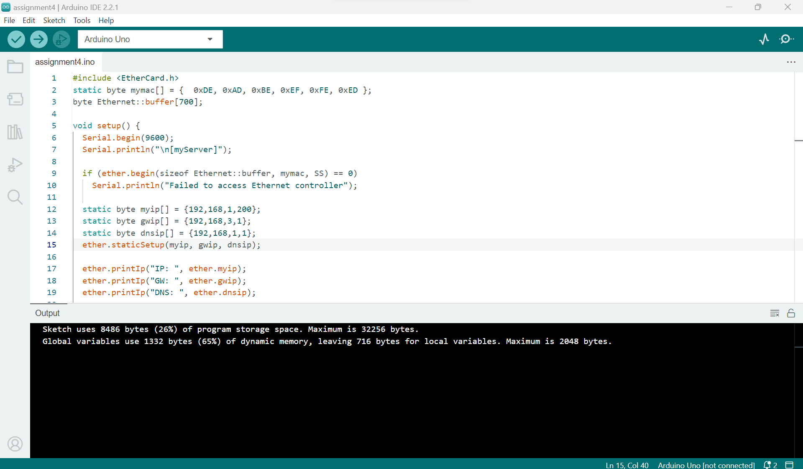

**Proteus**  **Image Output:**

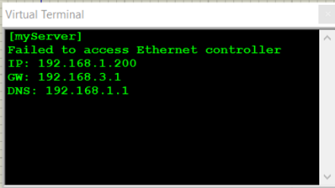***

**Solution**:

#include <EtherCard.h>

static byte mymac[] = {  0xDE, 0xAD, 0xBE, 0xEF, 0xFE, 0xED };

byte Ethernet::buffer[700];

void setup() {

  Serial.begin(9600);

  Serial.println("\n[myServer]");

  if (ether.begin(sizeof Ethernet::buffer, mymac, SS) == 0)

    Serial.println("Failed to access Ethernet controller");

  static byte myip[] = {192,168,1,200};

  static byte gwip[] = {192,168,3,1};

  static byte dnsip[] = {192,168,1,1};

  ether.staticSetup(myip, gwip, dnsip);

  ether.printIp("IP: ", ether.myip);

  ether.printIp("GW: ", ether.gwip);

  ether.printIp("DNS: ", ether.dnsip);

  if (!ether.dnsLookup("google.com"))

    Serial.println("DNS failed");

}

void loop() {

  ether.packetLoop(ether.packetReceive());

  word len = ether.packetReceive();

  word pos = ether.packetLoop(len);

  if (len > 0 && pos) {

    if (strstr((char *) Ethernet::buffer + pos, "GET /?led=on")) {

      digitalWrite(13, HIGH);

      Serial.println("LED turned ON.");

    } else if (strstr((char *) Ethernet::buffer + pos, "GET /?led=off")) {

      digitalWrite(13, LOW);

      Serial.println("LED turned OFF.");

    }

    const char httpResponse[] PROGMEM = "HTTP/1.1 200 OK\r\nContent-Type: text/html\r\n\r\n<h1>Arduino Web Server</h1><a href=\"/?led=on\">Turn On LED</a><br><a href=\"/?led=off\">Turn Off LED</a><br>";

    memcpy(Ethernet::buffer, httpResponse, sizeof(httpResponse));

    ether.httpServerReply(sizeof(httpResponse) - 1);

  }

}